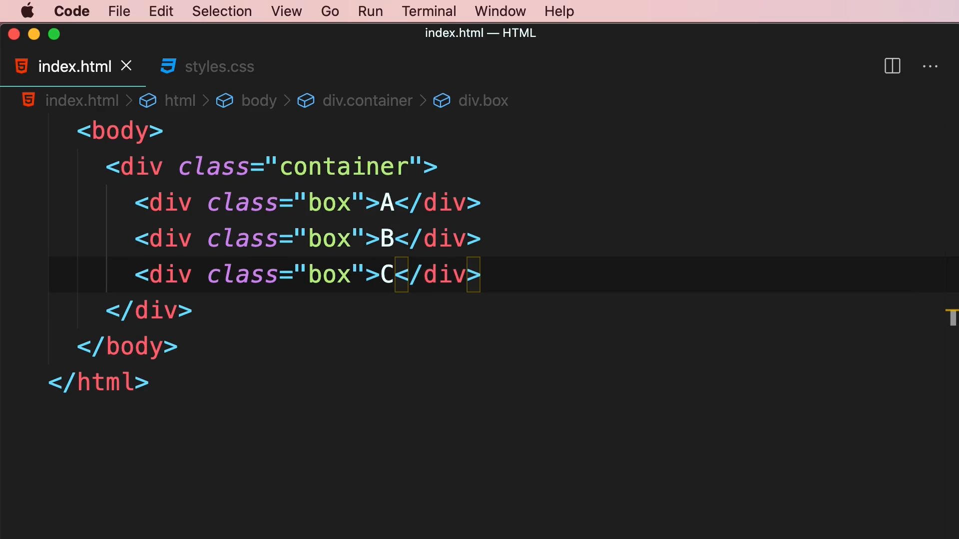

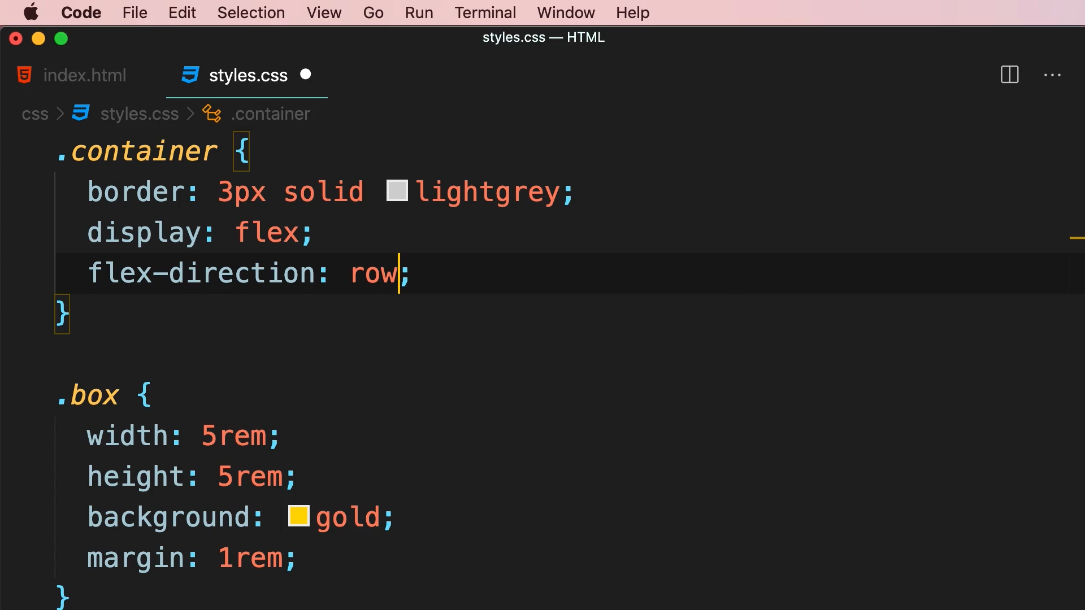

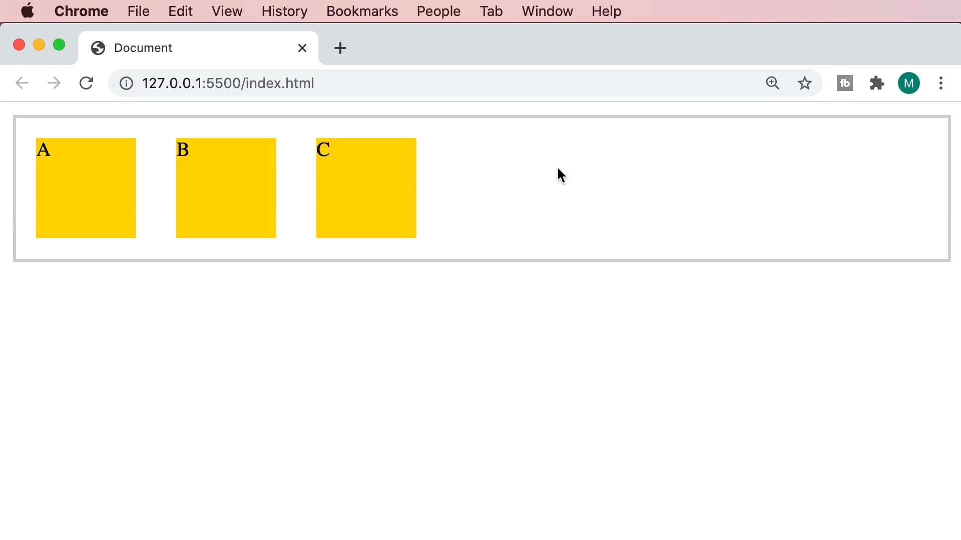

Tailwind CSS

|  |  |
| --- | --- |
| Class | Properties |
| flex-row | flex-direction: row; |
| flex-row-reverse | flex-direction: row-reverse; |
| flex-col | flex-direction: column; |
| flex-col-reverse | flex-direction: column-reverse; |

<div class="flex flex-row">

<div class="box">A</div>

<div class="box">B</div>

<div class="box">C</div>

</div>

.container

{

    border: 3px solid lightgrey;

}

.box

{

    width: 5rem;

    height: 5rem;

    background: gold;

    margin: 1rem;

}